Juno
Mission Description

By Bill Kurth

2012-03-12

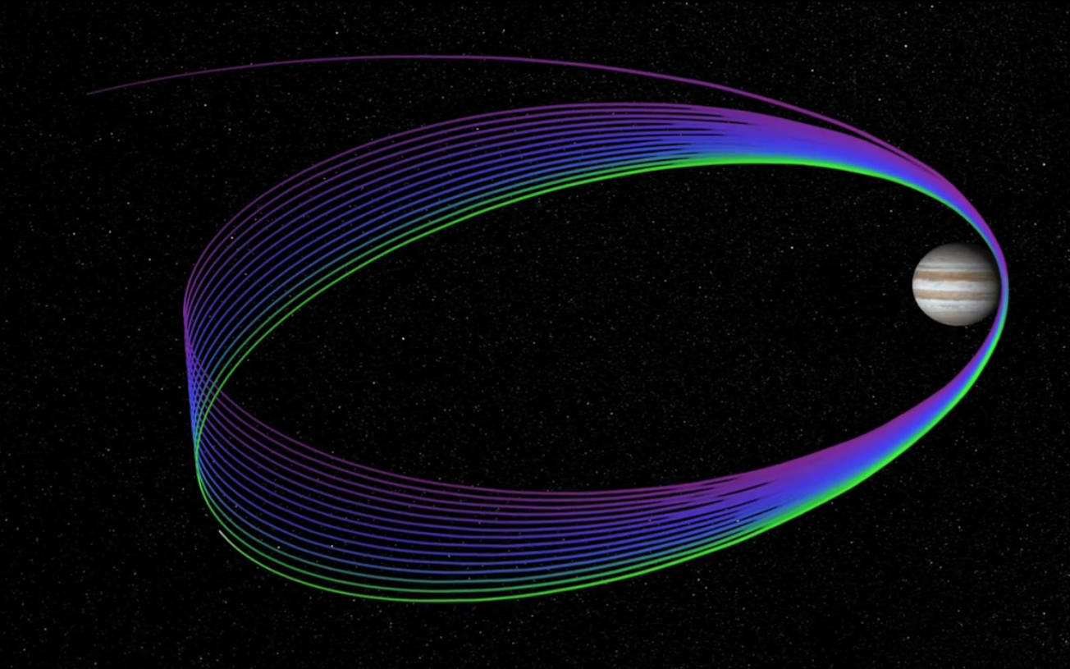

Juno Mission Description

The majority of the text in this file was extracted from the Juno Mission Plan
Document, S. Stephens, 29 March 2011. [JPL D-35556]

Overview

Juno was launched on 5 August 2011. The spacecraft uses a deltaV-EGA trajectory consisting of a two-part deep space maneuver on 30 August and 3 September 2012 followed by an Earth gravity assist on 9 October 2013 at an altitude of 500 km.

Jupiter arrival is scheduled for 5 July 2016 using a 107-day capture orbit prior to commencing operations for a 1-(Earth) year long prime mission comprising 32 high inclination, high eccentricity orbits of Jupiter. The orbit is polar (90 degree inclination) with a periapsis altitude of 4500 km and a semi-major axis of 19.91 RJ (Jovian radius) giving an orbital period of 10.9725 days. The primary science is acquired for approximately 6 hours centered on each periapsis although fields and particles data are acquired at low rates for the remaining apoapsis portion of each orbit.

Currently, periapses 4, 6, 7, 8, 9 and 14 dedicated to microwave radiometry of
Jupiter's deep atmosphere with the remaining orbits dedicated to gravity measurements to determine the structure of Jupiter's interior. All orbits will include fields and particles measurements of the planet's auroral regions. Juno is spin stabilized with a rotation rate of 1 - 3 rotations per minute (RPM). For the radiometry orbits the spin axis is precisely perpendicular to the orbit plane so that the radiometer fields of view pass through the nadir. For gravity passes, the spin axis is aligned to the Earth direction, allowing for Doppler measurements through the periapsis portion of the orbit. The orbit plane is initially very close to perpendicular to the Sun-Jupiter line and evolves over the 1-year mission. Generally, data acquired during the periapsis passes are recorded and played back over the subsequent apoapsis portion of the orbit, although some data are downlinked can be downlinked during the gravity passes.

Juno's instrument complement includes Gravity Science using the X and Ka bands to determine the structure of Jupiter's interior; magnetometer investigation (MAG) to study the magnetic dynamo and interior of Jupiter as well as to explore the polar magnetosphere; and a microwave radiometer (MWR) experiment covering 6 wavelengths between 1.3 and 50 cm to perform deep atmospheric sounding and composition measurements. The instrument complement also includes a suite of fields and particle instruments to study the polar magnetosphere and Jupiter's aurora. This suite includes an energetic particle detector (JEDI), a Jovian auroral (plasma) distributions experiment (JADE), a radio and plasma wave instrument (Waves), an ultraviolet spectrometer (UVS), and a Jupiter infrared auroral mapping instrument (JIRAM). The JunoCam is a camera included for education and public outreach. While this is not a science instrument, we plan to capture the data and archive them in the PDS along with the other mission data. The MAG investigation consists of redundant flux gate magnetometers (FGM) and co-located advanced stellar compasses (ASC). The ASCs are provided by the Danish Technical University under an effort led by John Jorgenson.

Scott Bolton is the Juno Principal Investigator. The Science Team members responsible for the delivery and operation of the instruments are listed below:

Instrument Acronym Lead Co-I

Gravity Science GRAV Folkner
Magnetometer MAG Connerney
Microwave Radiometer MWR Janssen
Jupiter Energetic Particle Detector Instrument JEDI Mauk
Jovian Auroral Distributions Instrument JADE McComas
Radio and plasma wave instrument WAVES Kurth
Ultraviolet Imaging Spectrograph UVS Gladstone
Jovian Infrared Auroral Mapper JIRAM Coradini*
Juno color, visible-light camera JUNOCAM Hansen

*deceased

Juno Mission Phases

LAUNCH 2011-08-05 to 2011-08-08 (2011-217 to 2011-220)

The Launch phase starts at L+40 min (Launch+40 min), and covers the interval from launch, through initial ground station acquisition, until the establishment of a pre-defined, stable, and slowly changing Sun-pointed attitude when cruise attitude control algorithms and ephemerides can be used. The end of the Launch phase is determined by post-launch health and safety assessments. The planned boundary is at L+3 days, after initial acquisition and after confirmation that the Flight System is safe and in a power-positive, thermally stable, and commandable attitude.

INNER CRUISE 1 2011-08-08 to 2011-10-10 (2011-220 to 2011-283)

The Inner Cruise 1 phase lasts from post-Launch establishment of a pre-defined and stable Sun-pointed attitude when cruise attitude control algorithms and ephemerides can be used, until after initial spacecraft and instrument checkouts have been performed and the spacecraft has gotten far enough from the Sun to allow Earth-pointing instead of Sun-pointing. TCM 1 (the first planned trajectory correction maneuver) was deemed not necessary, hence, was not executed. The phase spans the interval from L+3 to L+66 days for the reference trajectory.

INNER CRUISE 2 2011-10-10 to 2013-05-28 (2011-283 to 2013-148)

The Inner Cruise 2 phase spans the period from L+66 days until L+662 days. The Deep Space Maneuvers (DSMs) occur during this phase, near aphelion of Juno's first orbit about the Sun, on the way to Earth Flyby and then Jupiter. There is increased DSN (Deep Space Network) coverage associated with the DSMs and a cleanup TCM. DSMs 1 and 2 occur on 8/30/12 and 9/3/12 for the reference trajectory.

INNER CRUISE 3 2013-05-28 to 2013-11-05 (2013-148 to 2013-309)

The Inner Cruise 3 phase spans the interval from L+662 days to L+823 days. The duration of this cruise phase is 161 days for the reference trajectory. Featured in this phase is Earth Flyby (EFB), which gives Juno a gravity assist (providing ~7 km/s of delta V) on its way to Jupiter. It occurs as the spacecraft is completing one elliptical orbit around the Sun and includes perihelion. Three TCMs occur before and one after EFB. There is increased DSN coverage associated with the 4 maneuvers and EFB. The Inner Cruise 3 phase is focused on performing the required maneuvers, as well as an integrated operations exercise around Earth Flyby, subject to Flight System constraints. Closest approach to Earth occurs on 10/9/13 at 14:01 UTC.

QUIET CRUISE 2013-11-05 to 2016-01-05 (2013-309 to 2016-005)

The Quiet Cruise phase lasts from L+823 days until the start of Jupiter Approach at Jupiter Orbit Insertion (JOI)-6 months (JOI-182 days or L+1613 days). The duration of this cruise phase is 790 days for the reference trajectory, which is over 2 years.

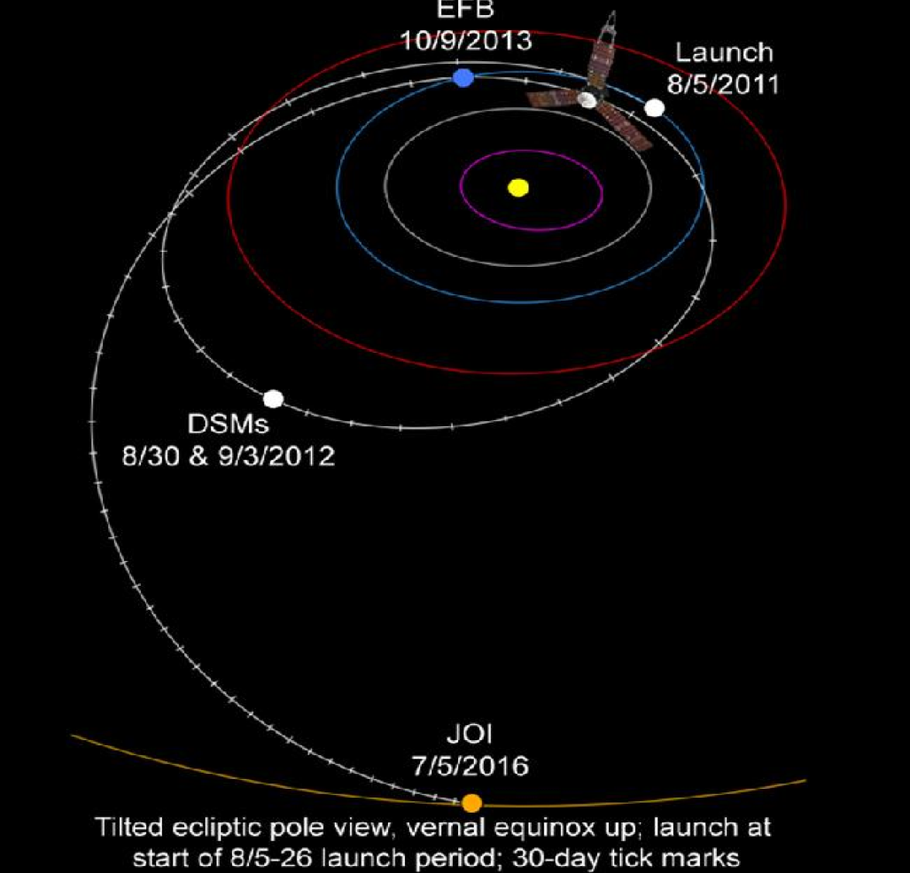

Figure 1. Juno’s Cruise Trajectory

JUPITER APPROACH 2016-01-05 to 2016-06-30 (2016-005 to 2016-182)

The Jupiter Approach phase lasts the final 6 months of cruise before Jupiter Orbit Insertion and is an opportunity for final Flight System and instrument checkouts as well as science observations to start exercising the ground system and Flight System, although orbit insertion preparations limit instrument activities close to JOI. There are more frequent maneuvers approaching JOI, starting with a TCM at JOI-5 months, and correspondingly increasing DSN coverage. The 178-day Jupiter Approach phase is preceded by a 26-month Quiet Cruise phase. Jupiter Approach starts 3 months after the project is fully staffed up in preparation for JOI and the year of science orbits. The phase ends at JOI-4 days, which is the start of the JOI critical sequence. The project recently approved an earlier start to Jupiter Approach and associated science activities (JOI-9 months), but that is not yet part of the baseline plan.

JUPITER ORBIT INSERTION 2016-06-30 to 2016-07-05 (2016-182 to 2016-187)

The JOI phase encompasses the JOI critical sequence. It begins 4 days before the start of the orbit insertion maneuver and ends 1 hour after the start. JOI, the second critical event of the mission, occurs at closest approach to Jupiter, and slows the spacecraft enough to let it be captured by Jupiter into a 107-day orbit and set up the geometry for the 11-day science orbits. A cleanup burn at JOI+7.6d during the Capture Orbit phase is required to ensure the timing of the large PRM (Period Reduction Maneuver) burn at perijove of the next orbit. DSN coverage is continuous during the JOI phase.

CAPTURE ORBIT 2016-07-05 to 2016-10-19 (2016-187 to 2016-293)

The Capture Orbit phase starts at JOI+1h, after the end of the JOI critical sequence, continues to the apojove of a 107-day capture orbit that results from the JOI maneuver, and ends at PRM-18h, when instruments are off in preparation for the PRM maneuver. A JOI cleanup maneuver at JOI+7.6d is required to ensure the timing of the large PRM burn at perijove of the next orbit. An apojove maneuver in the middle of the Capture Orbit may be needed to alter the perijove altitude for subsequent orbits, but it is not currently required. Solar conjunction occurs after apojove. DSN coverage remains continuous until the JOI+7.6d maneuver, then decreases to a rate lower than in the Science Orbits, and increases again before PRM. Instruments are on for most of the Capture Orbit, and there are routine checkouts and science observations.

PERIOD REDUCTION MANEUVER 2016-10-19 to 2016-10-20 (2016-293 to 2016-294)

The Period Reduction Maneuver phase starts at PRM-18h, and ends at PRM+11h, coinciding with the instrument keepout zone for the maneuver (no science observations are planned during this phase). The burn at PJ1 (Perijove 1) is designed to accomplish a decrease in the period and size of the orbit, thus the name Period Reduction Maneuver (PRM). PRM is a larger burn than JOI in duration as well as deltaV, and requires cleanup maneuvers in each of the following 2 orbits to ensure proper timing for longitude coverage during the Science Orbits phase. DSN coverage is continuous from PRM-14 days until AJ1 (Apojove 1) at PRM+5.5 days.

ORBITS 1-2 2016-10-20 to 2016-11-09 (2016-294 to 2016-314)

The Orbits 1-2 phase starts at PRM+11h, after the end of the instrument keepout zone for the Period Reduction Maneuver, and near the beginning of the first 11-day orbit. It ends at PJ3-1d, which is the start of the first activity period (MWR AP3) in the Science Orbits. As such, the Orbits 1-2 phase includes most of the last half of Orbit 1 (PJ1 to AJ1) and all of Orbit 2 (AJ1 to AJ2). DSN coverage is continuous from the start of the phase until AJ1, and then follows a pattern similar to that used for the Science Orbits template. Instrument high-voltage checkouts after PRM and science observations during the rest of Orbit 1 and in Orbit 2 are planned.

SCIENCE ORBITS 2016-11-09 to 2017-10-11 (2016-314 to 2017-284)

The Science Orbits phase includes Orbit 3 through Orbit 33. Orbit N is defined from apojove (AJ) N-1 through apojove N, and includes perijove (PJ) N. Orbit numbering starts before the Science Orbits phase. JOI occurs at PJ0, so Orbit 0 lasts from PJ0 through AJ0 (including a JOI cleanup maneuver at JOI+7.6d). Orbit 1 includes PJ1 (and PRM at PJ1), and runs from AJ0 through AJ1. Orbit 0 and the first half of Orbit 1 together contain the 107-day capture orbit. Orbit 2 includes PJ2 (and the PRM cleanup 1 maneuver at PJ2+1h), and runs from AJ1 through AJ2. Early orbital science is baselined in the Orbits 0, 1, and 2, except for JOI and PRM keepout zones. Orbit 3 is the first science orbit. It includes PJ3 (and the PRM cleanup 2 maneuver at PJ3+4h), and runs from AJ2 through AJ3. The last science orbit is Orbit 33. It is bookkept as an extra science orbit, since the mission uses Orbits 3 through 32 to obtain 30 perijoves with MAG and other data that meet Level-1 baseline science requirements. Small (0.1-3.0 m/s) orbit trim maneuvers (OTMs) are planned after each set of perijove science observations, at PJ+4h in Orbits 3 through 32, to target the perijove longitude required for science observations in the next orbit. There is no need for an OTM at PJ33+4h. A deorbit maneuver (deterministic deltaV = 74 m/s) is planned near AJ33.

We distinguish activity periods from orbits. Orbits are used to refer to the mission design and navigation strategy (e.g., Nav data cutoffs, which occur near AJ orbit boundaries, and trajectory events), while activity periods are used to describe science and mission operations (e.g., sequences and data flow). An activity period (AP) runs from one PJ-1d to the next PJ-1d. Each AP is defined by the number of the PJ science pass it contains, and the type (MWR or GRAV). AP2 is the first 11-day activity period (a special type in this case), and runs from PJ2-1d through PJ3-1d. It is followed by the first activity period during the Science Orbits, AP3 (an MWR type), from PJ3-1d through PJ4-1d. The Science Orbits phase begins at the start of AP3, and continues through AP33, which ends early, at AJ33-1h, before the deorbit burn in the Deorbit phase. Radiation accumulation increases substantially as the orbital line of apsides rotates and perijove latitude increases from 3 degrees at JOI to 34 degrees at PJ33, so there are no plans for an extended mission. One more orbit may be possible, but more than that is not likely. There is likely to be very little delta V savings after JOI, which also limits extended mission options.

Table 1. Trajectory Event Times (150326 reference trajectory)

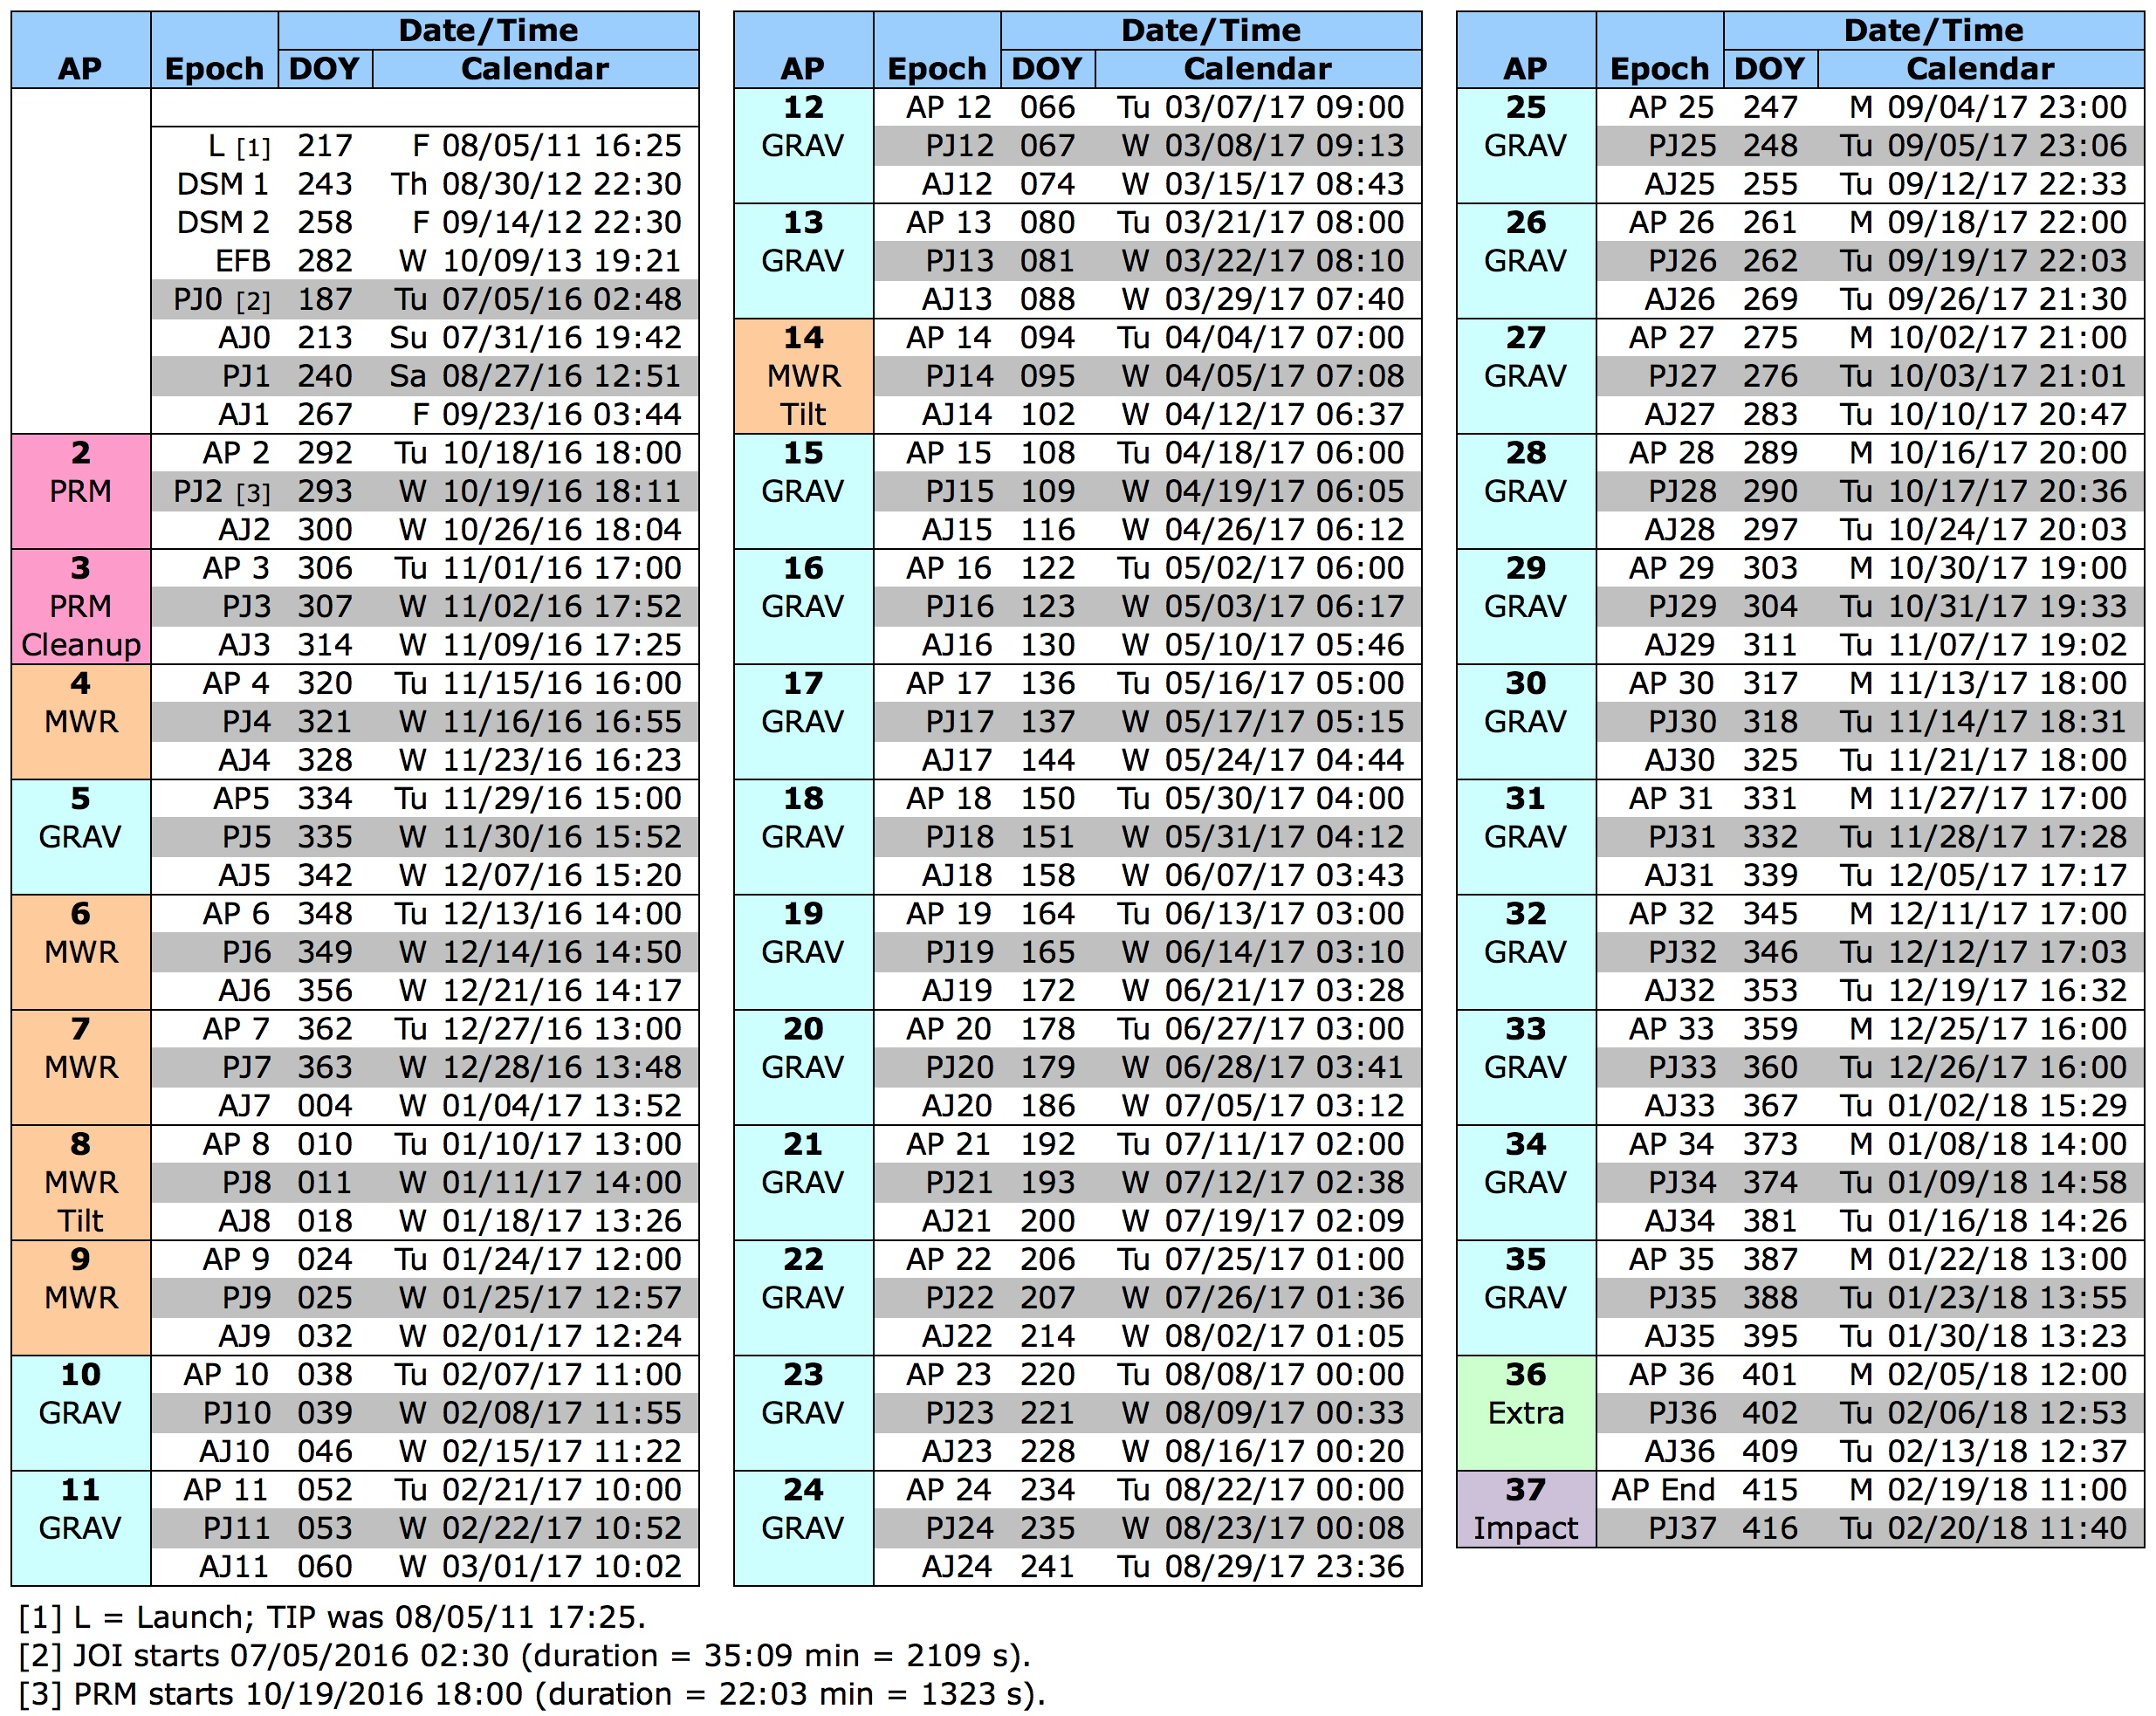
DEORBIT 2017-10-11 to 2017-10-16 (2017-284 to 2017-289)

The Deorbit phase occurs during the final perijove-to-perijove orbit of the mission. The 5.5-day phase starts several days after the Orbit 33 perijove science pass (part of the extra orbit) at AJ33-1h, before the start of the apojove deorbit maneuver (by which time we hope to have all or most of the PJ33 data on the ground). It continues through AJ33, and ends with Impact into Jupiter at PJ34. In order to meet planetary protection requirements and ensure that we do not impact Europa (as well as Ganymede and Callisto), the spacecraft performs a deorbit maneuver near apojove that reduces our orbital velocity and sends us to a perijove below Jupiter's cloud tops. The mean burn deltaV of 74 m/s is the largest maneuver of the mission after the 4 main engine maneuvers, and is planned to be performed on RCS (Reaction Control System) thrusters (deltaV to Earth angle, ELA ~ 70 degrees). The timing of the burn is not mission critical; a contingency delayed execution can occur several days around and following apojove if necessary. Impact into Jupiter marks End of Mission (EOM), and occurs one orbit before solar conjunction (a deorbit maneuver on the following orbit is also possible, but the following perijove occurs at solar conjunction minimum)."

Juno Mission Objectives

Juno's science objectives encompass four scientific themes: origin, interior structure, atmospheric composition and dynamics, and polar magnetosphere.
These are based on Appendix E to the New Frontiers Program Plan: Program Level Requirements for the Juno Project (PLRA). Juno addresses science objectives central to three NASA Science divisions: Solar System (Planetary), Earth-Sun System (Heliophysics), and Universe (Astrophysics). Juno’s primary science goal of understanding the formation, evolution, and structure of Jupiter is directly related to the conditions in the early solar system, which led to the formation of our planetary system. The mass of Jupiter's solid core and the abundance of heavy elements in the atmosphere discriminate among models for giant planet formation. Juno constrains the core mass by mapping the gravitational field, and measures through microwave sounding the global abundances of oxygen (water) and nitrogen (ammonia). Juno reveals the history of Jupiter by mapping the gravitational and magnetic fields with sufficient resolution to constrain Jupiter's interior structure, the source region of the magnetic field, and the nature of deep convection. By sounding deep into Jupiter's atmosphere, Juno determines to what depth the belts and zones penetrate. Juno provides the first survey and exploration of the three-dimensional structure of Jupiter's polar magnetosphere. The overall goal of the Juno mission is to improve our understanding of the solar system by understanding the origin and evolution of Jupiter.

Atmospheric Composition

Juno investigates the formation and origin of Jupiter's atmosphere and the potential migration of planets through the measurement of Jupiter's global abundance of oxygen (water) and nitrogen (ammonia).
a) Measure the global O/H ratio (water abundance) in Jupiter's atmosphere.
b) Measure the global N/H ratio (ammonia) in Jupiter's atmosphere.

Atmospheric Structure

Juno investigates variations in Jupiter's deep atmosphere related to meteorology, composition, temperature profiles, cloud opacity, and atmospheric dynamics.
a) Determine microwave opacity as a function of latitude and altitude (pressure).
b) Determine depths of cloud and atmospheric features such as zones, belts, and spots, and map dynamical variations in ammonia and water.
c) Characterize microwave opacity of the polar atmosphere region.

Magnetic Field

Juno investigates the fine structure of Jupiter's magnetic field, providing information on its internal structure and the nature of the dynamo.
a) Map the magnetic field of Jupiter, globally, by direct measurement of the field at close-in radial distances.
b) Determine the magnetic spectrum of the field, providing information on the dynamo core radius.
c) Investigate secular variations (long-term time variability) of the magnetic field.

Gravity Field

Juno gravity sounding explores the distribution of mass inside the planet.
a) Determine the gravity field to provide constraints on the mass of the core.
b) Determine the gravity field to detect the centrifugal response of the planet to its own differential rotation (winds) at depths of kilobars and greater.
c) Investigate the response to tides raised by the Jovian satellites.

Polar Magnetosphere

Juno explores Jupiter's three-dimensional polar magnetosphere and aurorae.
a) Investigate the primary auroral processes responsible for particle acceleration.
b) Characterize the field-aligned currents that transfer angular momentum from Jupiter to its magnetosphere.
c) Identify and characterize auroral radio and plasma wave emissions associated with particle acceleration.
d) Characterize the nature, location, and spatial scale of auroral features.

References

Stephens, S. K., Juno Project Mission Plan, Rev. D, JPL D-35556, 15 August 2013.

