Phoenix (PHX) Mission
Spacecraft Description

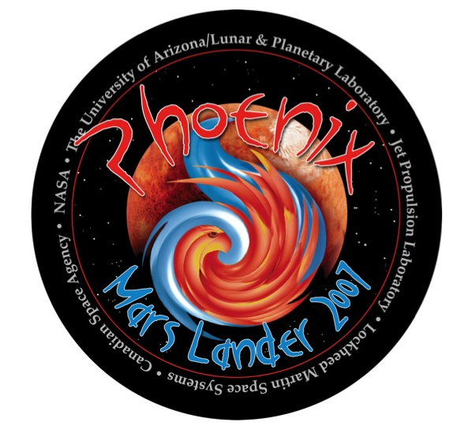

Revision and History Page

Description | Date
Original | 2008-04-12
Added RECORD_TYPE keyword | 2008-04-22
Corrected nonstandard ASCII characters | 2008-04-24
Removed embedded quotes | 2008-11-24

Phoenix Spacecraft Description

For most Phoenix Mars Scout Lander experiments, data will be collected by instruments on the spacecraft. Those data will then relayed directly to stations of the NASA Deep Space Network (DSN) on Earth or indirectly using the Mars orbiters Mars Global Surveyor (MGS) or 2001 Mars Odyssey (ODY). The following sections provide an overview first of the MER spacecraft, then of the DSN ground system, and finally of 2001 Mars Odyssey as each supports Phoenix science activities.

Spacecraft Configuration for Entry, Descent, and Landing

Seven minutes prior to atmospheric entry the spacecraft separates from the cruise stage and reorients itself to the entry attitude. The EDL phase lasts approximately seven minutes from entry through touchdown, and is broken into hypersonic, parachute, and terminal descent subphases, all of which require the spacecraft to be in a different configuration. Terminal descent on Phoenix is accomplished using a pulsed propulsion system whose heritage is from Mars Polar Lander (MPL). Communications during EDL - from cruise stage separation through landing plus one minute - will be via UHF relay to the Mars Reconnaissance Orbiter (MRO) and Mars Odyssey (ODY) relays. All X-band capability is lost once the cruise stage is jettisoned.

During most of EDL, Phoenix uses a UHF antenna that wraps around the backshell to give it a wide field of view (FOV) for communications. During terminal descent (approximately 30 seconds before landing), the Lander switches to the landed Helix antenna and continues transmitting a UHF signal until one minute after landing. As can be seen in Figures 13 and 14, this wide FOV is necessary as the geometry between Phoenix and the orbiters Mars Reconnaissance Orbiter (MRO), Mars Odyssey (ODY), and Mars Express (MEX) requires a very wide spread of off-boresight angles.
Although not currently in the solution space, MEX is shown where it would be phased to support EDL in the event that it becomes available in the future. MEX has a very different EDL vantage point than do MRO and ODY.

Following its soft touchdown between 65 deg N to 72 deg N latitude, the Lander will, after waiting 20 minutes for the dust to settle, perform a number of critical activities. These 'Sol 0' (a sol is a mars day) activities include deployments of the landed solar arrays, the bio-barrier covering the RA, and the SSI and MET masts. The SSI will take images of the bio-barrier, solar arrays, and part of the footpad and workspace. High priority EDL and Sol 0 data will be saved to flash memory within the first hour after touchdown, after which the Lander will go to sleep to conserve energy. The Lander will wake up for 10 minutes for the first post-landed UHF communication pass one ODY or MRO orbit period (approximately 2 hours) after landing. After relaying eagerly anticipated data to the orbiter(s) during that first pass, the Lander will go to sleep again. Payload heaters are on continuously from touchdown, with Lander heaters kicking in around midnight for 4-5 hours of keep-alive heating. [GUINNETAL2008]

Lander on the Surface of Mars
The first seven sols after Landing are known as the characterization phase, with pre-planned activities running from a minimum of 3 hours on Sol 1 to a maximum of 6.5 hours on Sol 6 (the Lander is active for up to 7 hours during the nominal surface or digging phase). The performance of the spacecraft's power, thermal, and UHF subsystems will be thoroughly characterized during this phase, and the Thermal and Evolved Gas Analyzer (TEGA), Microscopy, Electrochemistry, and Conductivity Analyzer (MECA), and Meteorological (MET) instruments will go through their initial checkouts and prepare for nominal operations. Concurrent with these activities, the EDL and Sol 0 data that were stored in the non-volatile (flash memory) will be relayed to the ground. The SSI will image as much of the Lander as it can see and characterize the workspace and surrounding environment. Most important for mission success will be the 'unstow' of the RA and the subsequent practice sample transfers that it will perform on Sol 5. The Robotic Arm Camera (RAC) located on the 'wrist' of the RA will be used to image the footpads and the TEGA cover, as it is the only imager that can be maneuvered into the proper viewpoint for these pictures. The seventh sol does not currently contain any planned activities because it will be used for margin against activities that fail or otherwise require additional time to complete during characterization.

After the Robotic Arm (RA) is checked out, the digging phase commences. The digging phase activities include digging a trench in front of the Lander, and the analysis of soil samples at various trench-depths by the Lander instruments. This phase continues until the End-of-Mission on Sol 90. Operations during this phase will be conducted at the University of Arizona and the mission operators will be working on Mars time (one martian sol is equivalent to 1.02749125 Earth days, or 24 hours, 39 minutes, 35.244 seconds).

Given the limited a priori knowledge of the environment at the landing site, it would be futile to generate a detailed plan for the Lander digging activities far in advance of landing. Yet, it is necessary to be able to demonstrate that the objectives of the mission can be achieved for the various circumstances that the Lander might encounter. A more worthwhile approach is to construct a set of scenarios that each makes certain assumptions about the landed environment and resource availability. Each scenario is comprised of a standard set of Lander activities that can be combined into a representative grouping by sol type. The activities and associated resource usage for each sol type can be evaluated once and applied to all occurrences of any particular sol type. Each scenario - an integrated timeline of surface activities - can then be used to model and track mission resources such as payload power draw or data volume generation, and to track the achievement of the mission goals and objectives over time. The scenarios are used in strategic planning to provide a high-level roadmap for achieving mission success. In actual operations, the activities on any given sol are not likely to be restricted to those that comprise a particular sol type, but rather, will likely include additional activities that both optimize the use of the available resources and augment the science content. To date, several surface mission scenarios using nine basic sol types have been constructed in an effort to determine how to best achieve the objectives set forth by the mission success criteria. [GUINNETAL2008]

Instrument Host Overview - DSN

The Deep Space Network is a telecommunications facility managed by the Jet Propulsion Laboratory of the California Institute of Technology for the U.S. National Aeronautics and Space Administration (NASA).

The primary function of the DSN is to provide two-way communications between the Earth and spacecraft exploring the solar system. To carry out this function it is equipped with high-power transmitters, low-noise amplifiers and receivers, and appropriate monitoring and control systems.

The DSN consists of three complexes situated at approximately equally spaced longitudinal intervals around the globe at Goldstone (near Barstow, California), Robledo (near Madrid, Spain), and Tidbinbilla (near Canberra, Australia). Two of the complexes are located in the northern hemisphere while the third is in the southern hemisphere.

Each complex includes several antennas, defined by their diameters, construction, or operational characteristics: 70-m diameter, standard 34-m diameter, high-efficiency 34-m diameter (HEF), and 34-m beam waveguide (BWG).

For more information see [ASMAR&RENZETTI1993].

Instrument Host Overview - 2001 Mars Odyssey

The 2001 Mars Odyssey (ODY) spacecraft was built by Lockheed Martin Astronautics (LMA). Most spacecraft systems were redundant in order to provide backup should a device fail. In addition to transmitting data collected by ODY instruments and systems, the telecommunications system was used to relay data from Mars surface assets and measure their relative motion radiometrically in the 400 MHz frequency range. For more information, see [JPLD-16303].

References

ASMAR&RENZETTI1993
Asmar, S.W., and N.A. Renzetti, The Deep Space Network as an Instrument for Radio Science Research Vol. 80-93 Rev 1, Jet Propulsion Laboratory, Pasadena, CA 1993."

GUINNETAL2008
Guinn, J., M. D. Garcia, and K. P. Talley, Mission design of the Phoenix Mars Scout mission, J. Geophys. es., doi:10.1029/2007JE003038, in press."

JPLD-16303
JPLD-16303, Mars Surveyor 2001, Mission Plan, Revision B (MSP 722-201), JPL Document D-16303, Jet Propulsion Laboratory, Pasadena, CA, 2000."

