Version 1.0, 30 March 2018.

Occultation observations of Titan with Cassini VIMS
Philip D. Nicholson*, Todd Ansty
Department of Astronomy, Cornell University, Ithaca NY 14853
Matthew M. Hedman
Department of Physics, University of Idaho, Moscow ID 83844

* Corresponding author, nicholso@astro.cornell.edu

- Stellar occultations

The basic observation strategy adopted for Titan stellar occultations was the same as that employed for ring stellar occultations. Prior to the beginning of the occultation, VIMS obtained a 16 X 4 high-resolution image cube of the region around the target star, in which the pixel containing the star was identified using onboard software. The VIMS IR scanning mirror was then set to this pixel location and a continuous series of IR spectra was obtained in OCCULTATION mode. In this mode, the pointing remains fixed and the IR channel records a spectrum every 20, 40 or 80 msec, depending on the stellar brightness. Every 64 samples, the data are briefly interrupted to obtain an instrumental background spectrum. The data are saved in standard VIMS “cubes" of 64 X 64 spectra, but in this case there are no implied spatial variations. The last 8 channels in each spectrum are replaced with a time stamp, derived from the internal VIMS clock and periodically synchronized with Cassini's central SCLOCK system. Unlike ring occultations, the data from Titan occultations are not spectrally-summed or edited.

VIMS observed a total of 14 of stellar occultations by Titan, all but one during close flybys of the moon. Only two of these failed to return useful data. A complete list is provided in Table 1, including the stellar parameters, Cassini sequence, rev number and Titan flyby, approximate latitude, spacecraft range and duration, as well as observing mode parameters.

The requirement that VIMS obtain a star-finding cube prior to observing the occultation generally restricted Titan observations to ingress occultations, but in a few cases when the event geometry and allocated time permitted it was possible to observe both the ingress and egress occultations, especially for more distant events such as the RX Lep occultation on rev 228. In the case of the α Sco occultation on rev 49 the near-grazing geometry meant that the star never completely disappeared but could be tracked successfully throughout the occultation period at longer wavelengths. This observation is shown in Fig. 1. This was only possible because refraction is relatively unimportant for VIMS Titan occultations, so that the apparent stellar position remains almost unchanged throughout the event.

In a few cases, standard IMAGE mode was used rather than OCCULTATION mode, generally when it seemed likely that the usual starfinding algorithm might fail. Although only small images were obtained (10 X 8 pixels or less), the much lower rate at which the stellar signal was sampled makes these data probably useless for scientific analysis.

As for Saturn occultations, VIMS stellar occultations by Titan are affected by both differential refraction and molecular absorption, but for Titan we also see the effects of aerosol absorption, especially at shorter wavelengths. Aerosol extinction typically scales with wavelength as λ^{-n}, where for Titan n is ~ 1:5 (Bellucci et al. 2009). Aerosols appear to dominate the occultation light curves at wavelengths less than 2 μm, although quantitative models show that it is also necessary to include the effects of differential refraction (Bellucci et al. 2009). This is illustrated in Fig. 1, where the lightcurve at 1 μm is shown in the upper figure. Molecular absorption in Titan stellar (and solar) occultations is dominated by methane, with strong bands centered at 3.4, 2.3 and 1.65 μm and weaker bands visible at 1.3, 1.1 and 0.9 μm. Rapid signal variations due to refractive scintillation are either absent or very weak compared to those seen in VIMS Saturn occultations. They are more apparent at wavelengths greater than ~ 2:5 μm, as illustrated in the lower figure in Fig. 1.

Table 1.

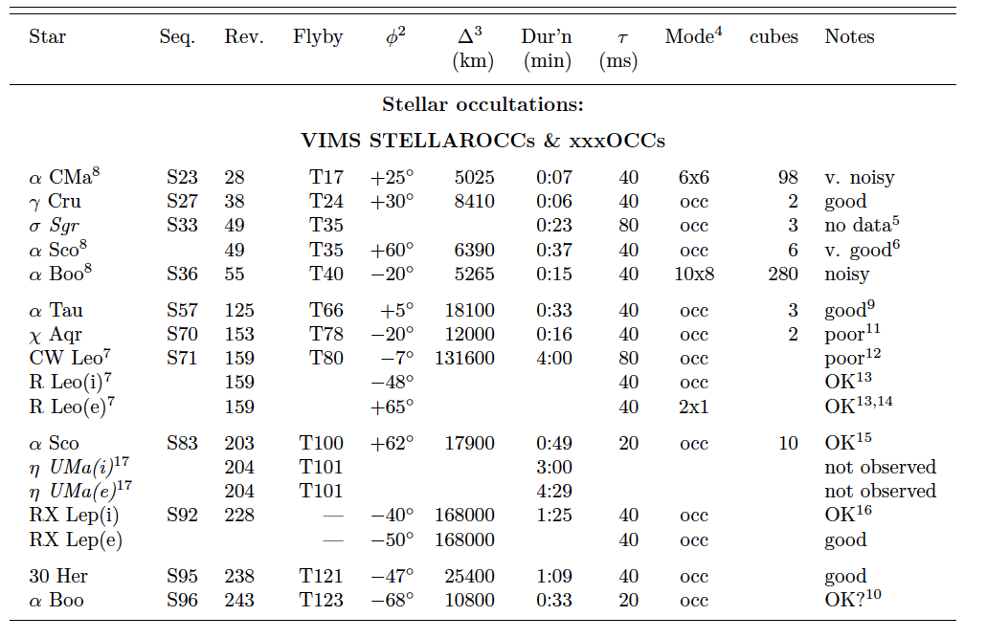

NOTES:
- Stellar diameter. Entries in () are estimated from spectral type and K magnitude.
- Approx latitude.
- Average S/C - Titan distance.
- Image size or obsv’n. mode.
- UVIS rider; Observation ID = UVIS-TI-SIGMASAG; star not detected.
- Grazing geometry over N pole. Star remains visible beyond 2.7 microns.
- Combined into one observation: ID = TI-STELLOCC
- Observation ID = TI-STAROCC.
- Rider on CIRS LIMBMAP. No spikes.
- Peculiar light curve, possibly due to extended haze layers.
- Stellar contrast low against sunlit limb.
- Irregular baseline & sunlit limb; used CIRS-FP4 boresight.
- Some data dropouts & sunlit limb.
- Egress occ; observed ‘blind’ in IMAGE mode.
- Unstable baseline; sunlit limb; final qube missing?
- Distant occ; both ingress & egress occ’ns observed. Ingress limb bright.
- UVIS rider, ID = TI-STELLOCC.

Total = 17 occs, including 3 “no data”. Revised 12 May 2018: PDN.

Rev 49 Titan STAROCC
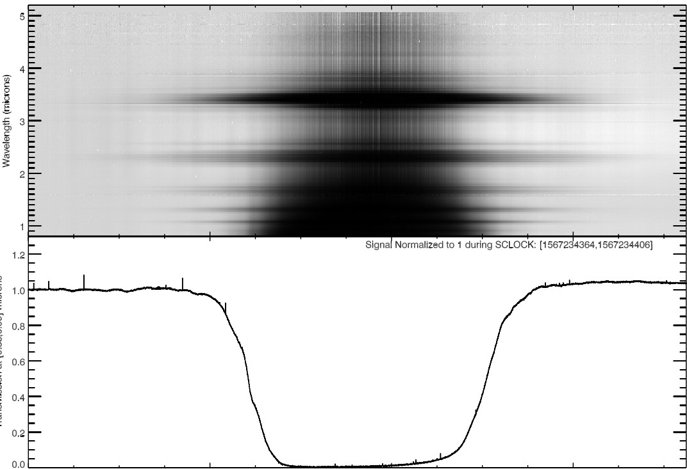
SCLOCK-156723 4406 (seconds)

Rev 49 Titan STAROCC
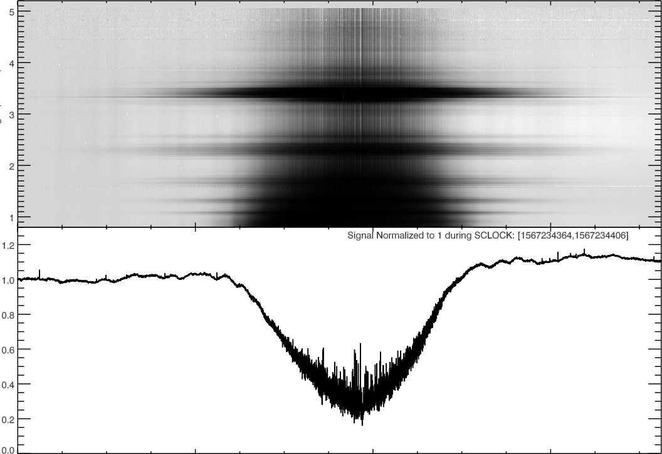
SC LOCK-1567234406 (seconds)

Fig. 1. A grazing occultation by Titan's atmosphere of the star α Sco, observed on rev
49, with an integration time of 40 ms. The average range to Titan was 6400 km, and the closest approach of the star to the limb was at a latitude of ~ 60_ N. The upper panel shows the full data set as a 2D grey-scale image, with time on the abscissa and wavelength on the ordinate. The gradual reduction of stellar signal with time is largely due to aerosol extinction, which is much stronger at shorter wavelengths. The narrow horizontal bands are due to molecular absorption by CH4. The lower panel shows the average lightcurve at 0.9-1.0 μm, where molecular extinction is unimportant but aerosol extinction is strongest. The lower figure shows a version of this plot with the average lightcurve at 2.8-3.0 μm. Some refractive scintillation is visible here. Note that the star never completely disappeared at longer wavelengths.

As was the case for Saturn stellar occultations, the quality of Titan occultations was severely degraded when they were observed against a bright limb; this was the case for five of the VIMS Titan occultations.

- Solar occultations

As described by Brown et al. (2004), the VIMS IR solar port consisted of a small off-axis aperture within the primary telescope that intercepted ~1 % of the incident sunlight, and then passed this through a chain of 45_ prisms made of ZnSe which further attenuated the signal.¹ The resulting flux, attenuated by an overall factor of 2 X 10⁻⁷, was then passed through the VIMS telescope and spectrometer optics in the same fashion as a normal target scene. In order to match the alignment of the solar port in the UVIS instrument, and to avoid damaging other sensitive optical systems on Cassini by directly observing the Sun, the VIMS solar port looked out in a direction 20º away from the main instrument boresight, offset in the -Z direction, towards the high gain antenna.

Because the Sun is not a point source as seen by VIMS, solar occultations could not be observed in single-pixel mode as were stellar occultations. Our approach was instead to observe solar occultations in IMAGE mode, obtaining a continuous series of small IR cubes of the Sun from which we could later estimate the solar flux as a function of time and wavelength. Cube sizes were either 8 X 8 or 12 X 12 pixels, with integration times of 20 or 40 msec per pixel. A single cube was acquired in 2-6 sec, including the necessary background measurements, which was generally satisfactory for most Titan occultations.

Unlike the situation with stellar occultations, the spatial resolution of solar occultations is usually set by the finite solar angular diameter rather than by the sampling time. At Saturn's mean distance from the Sun of 9.5 AU, the solar diameter is ~ 1:0 mrad, or 2 standard VIMS pixels. For Titan occultations at typical ranges of D ~10; 000 km the projected solar diameter was ~10 km, somewhat less than 1 atmospheric scale height. The large projected size of the solar disk means that the refractive scintillations characteristic of stellar occultations are not expected to be seen in solar occultations.

VIMS observed a total of 16 solar occultations by Titan, most as ingress/egress pairs.
All were carried out as riders on observations designed by the UVIS team. Ranges from
Titan to Cassini varied from 3600 to 20,000 km. A wide range of planetocentric latitudes has been probed, from -76_ to +81º, but with only a single near-equatorial solar occultation, on rev 109. A summary of all VIMS Titan solar occultations is provided in Table 2. In Fig. 2 we illustrate a typical ingress/egress pair, in the same format as used for stellar occultations in Fig. 1.

VIMS solar occultations are a useful tool for probing the vertical structure of Titan's lower atmosphere, including the nature and spatial distribution or aerosol layers. Analyses of several solar occultations have been reported by Bellucci et al. (2009) and Maltagliati et al. (2015), who find that it is necessary to include differential refraction, molecular absorption and aerosol extinction in order to model the data satisfactorily. At VIMS' longest wavelengths, ~ 5 μm, the solar signal penetrates almost to the surface of Titan according to these models. At

^{1.} The solar port in the VIS channel worked, in part, by diffusing the solar image along the instrument's spectrometer slit. This, combined with partial saturation of the solar spectrum, unfortunately made it impossible to make quantitative measurements of the solar flux at visual wavelengths.

shorter wavelengths, aerosols limit the maximum depth of penetration. In addition to methane absorptions seen at 0.9, 1.1, 1.3, 1.65, 2.3 and 3.4 μm, some VIMS solar occultations show absorption by CO at 4.7 μm.

Given the large angular size of Titan at close approach, it was possible for the main
VIMS boresight to pass across Titan itself while the solar port was tracking the Sun. This happened during four of the Titan solar occultations observed by VIMS, due to an unfortunate choice of secondary axis orientations for the spacecraft. In such cases, the instrument measured the combined signal from Titan and the Sun, which makes these occultation lightcurves very difficult to interpret (Maltagliati et al. 2015).

Table 2.

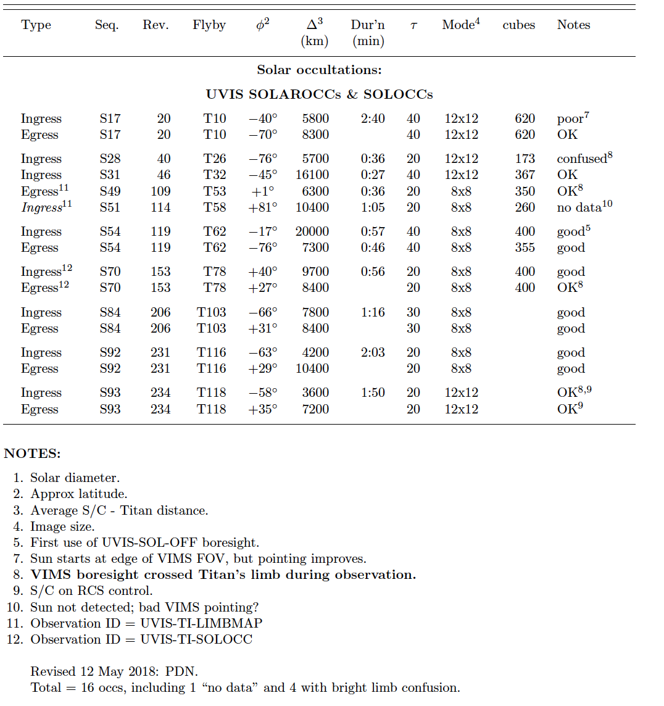

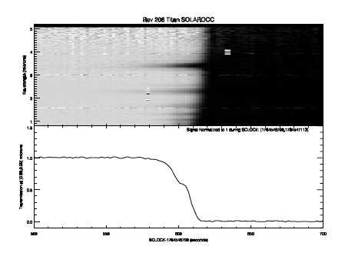

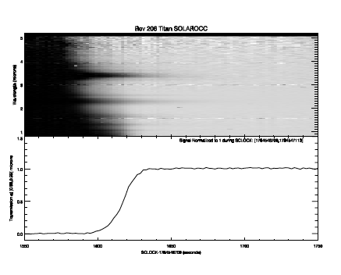

Fig. 2. A pair of solar ingress and egress occultations by Titan's atmosphere observed on rev 206, during the flyby designated as T103. The integration time was 30 ms per pixel and the data are displayed in the same format used in Fig. 1. In each case, the upper panel shows the full data set as a 2D grey-scale image, with time on the abscissa and wavelength on the ordinate, while the lower panel shows the average lightcurve at 0.9-1.0 μm. The gradual variation in stellar signal with time is due to a combination of differential refraction, which is almost independent of wavelength, and aerosol extinction. As in Fig. 1, the narrow horizontal bands are due to molecular absorption by CH4. Aerosol extinction is strongest at short wavelengths. Note the distinct aerosol layer in the ingress profile. The latitudes of ingress and egress were -66_ and +31º, respectively, and the ranges to Titan were 7800 km and 8400 km.

REFERENCES
Acton, C. H. 1996. Ancillary data services of NASA's Navigation and Ancillary Information
Facility. Planetary and Space Science 44, 65-70.

Bellucci, A., Sicardy, B., Drossart, P., Rannou, P., Nicholson, P. D., Hedman, M., Baines,
K. H., Burrati, B. 2009. Titan solar occultation observed by Cassini/VIMS: Gas
absorption and constraints on aerosol composition. Icarus 201, 198-216.

Brown, R. H., et al. 2004. The Cassini Visual And Infrared Mapping Spectrometer (VIMS) investigation. Space Science Reviews 115, 111-168.

Elliot, J. L. 1979. Stellar occultation studies of the solar system. Annual Review of Astron-
omy and Astrophysics 17, 445-475.

ESA 1997. The Hipparcos and Tycho catalogues. VizieR Online Data Catalog 1239, 0.

Maltagliati, L., B_ezard, B., Vinatier, S., Hedman, M. M., Lellouch, E., Nicholson, P. D.,
Sotin, C., de Kok, R. J., Sicardy, B. 2015. Titan's atmosphere as observed by
Cassini/VIMS solar occultations: CH4, CO and evidence for C2H6 absorption. Icarus 248, 1-24.

