Welcome to the Venus Express Radio Science Page

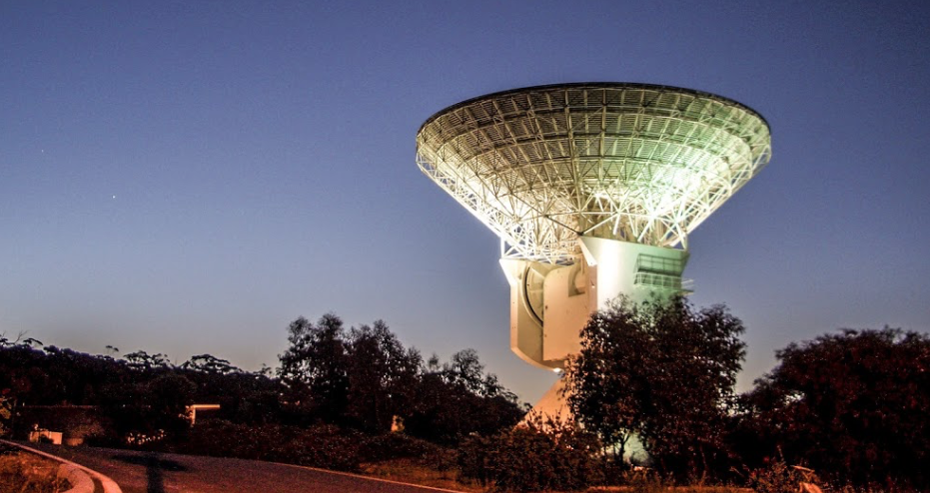

ESA New Norcia Deep Space Facility

Introduction

The spacecraft was able to receive and transmit signals at both S-band (approximately 13 cm wavelength) and X-band (approximately 3.5 cm). Two low-gain and two high-gain antennas were available; but not all combinations of antenna and band could be selected. The spacecraft transmissions could use either an onboard oscillator for the frequency reference ('one-way' mode) or a signal transmitted from the ground ('two-way' mode). In the former case, an ultra-stable oscillator (USO) could be selected; in the latter case, either an S- or X-band signal from the ground could be used as the reference, depending on the antenna selected.

Because the Venus Express (VEX) orbit period was 24 hours and pericenter was synchronized with viewing from Australia, all radio science activities were conducted using the ESA facility at New Norcia and the DSN complex at Canberra. Performance and calibration of both the spacecraft and ground systems directly affected the radio science data accuracy and played a major role in determining the quality of the results.

References:
Haeusler, B., M. Paetzold, G.L. Tyler, R.A. Simpson, M.K. Bird, V. Dehant, J.-P. Barriot, W. Eidel, R. Mattei, S. Remus, J. Selle, S. Tellmann, and T. Imamura, Radio science investigations by VeRa onboard the Venus Express spacecraft, Planetary and Space Science, 54, 1315-1335, 2006.

Mattei, R., B. Haeusler, M. Paetzold, S. Remus, W. Eidel, S. Tellmann, T. Andert, J. Selle, M. K. Bird, R. A. Simpson, G. L. Tyler, V. Dehant, S. Asmar, J.-P. Barriot, and T. Imamura, The radio science experiment 'VeRa' onboard ESA's Venus Express spacecraft, 1st CEAS, European Air and Space Conference, Publication CEAS-2007-121, 2055-2064, 10-13 September 2007.

Measurement Objectives
Radio Science Measurements can be conducted in either one-way or two-way mode. These measurements were applied - separately and together - to Venus science objectives such as inference of local gravity field anomalies, atmospheric drag, temperature and pressure of the atmosphere, electron density in the ionosphere, scattering properties of the surface, and structure of the solar wind. Several different types of observations were carried out by VEX.
Gravity Measurements - Venus Express studies focused on the characteristics of the field at 140-220 degrees east longitude and 40-80 degrees north latitude, where gaps in the MAGELLAN tracking were most common. VEX was expected to provide improvements to the field in this area. A possible by-product of the gravity field analysis is information on the density structure of the upper atmosphere. The first campaign designed to detect and measure drag was conducted during the summer of 2008.
Radio Occultation Measurements were made to obtain profiles of temperature and pressure in the neutral atmosphere and profiles of electron density in the ionosphere. VEX occultation data provided neutral atmospheric structure from about 37 km altitude (limited by critical refraction) to about 100 km and electron density profiles from 100 to 400 km. VEX radio occultation experiments were conducted on a regular basis. The polar orbit allowed extensive occultation coverage at high northern and southern latitudes (e.g., beyond 60 degrees). During the first 1000 orbits/days of VEX operations, there were six occultation 'seasons' of typically 60-70 orbits each interleaved with intervals of approximately the same duration when there were no occultations. As the orbit drifted edge-on to nearly broadside (as viewed from Earth), occultation points moved toward the equator and the entry/exit angle approached grazing.

Bistatic Surface Scattering Measurements were made to determine the dielectric constant and determine whether the material is insulating or conducting. A conducting material was inferred from MAGELLAN bistatic radar observations using linear polarization near Cleopatra Patera in Maxwell Montes. One goal of the VEX bistatic radar experiments was to confirm the MAGELLAN results using circular polarization and to investigate whether similar signatures could be found at other high-altitude targets.

Solar Scintillation Observations were conducted during the late 2006’s.

Useful Mission Documents
Mission Description https://atmos.nmsu.edu/PDS/data/VXRS_1101/CATALOG/MISSION.CAT
Spacecraft Description https://atmos.nmsu.edu/PDS/data/VXRS_1101/CATALOG/INSTHOST.CAT
Target information https://atmos.nmsu.edu/PDS/data/VXRS_1101/CATALOG/TARGET.CAT
Instrument Description https://atmos.nmsu.edu/PDS/data/VXRS_1101/CATALOG/INST.CAT
Software Interface Specification Document (SIS) - Instrument and data structures description https://atmos.nmsu.edu/PDS/data/VXRS_1103/DOCUMENT/TNF_SIS.TXT

Team Personnel https://atmos.nmsu.edu/PDS/data/VXRS_1101/CATALOG/PERSON.CAT
References https://atmos.nmsu.edu/PDS/data/VXRS_1101/CATALOG/PERSON.CAT
Guide to Radio Science Data (written for the Cassini mission but insightful - See section 3.1)
https://pds-atmospheres.nmsu.edu/data_and_services/atmospheres_data/JUNO/logs/Cassini%20Radio%20Science%20Users%20Guide%20-%203%20may%202014.pdf

Archived Datasets
Documentation https://atmos.nmsu.edu/PDS/data/VXRS_1104/DOCUMENT/
The OCCLOG03 file contains summary information for each Venus Express (VEX) experiment successfully conducted using the DSN Radio Science Receiver (RSR) during the VEX Extended Mission phase. Some (but not all) unsuccessful operations are also included. The table includes start/stop times antenna number, sample rate, bit resolution, record length, number of records, maximum signal-to-noise ratio, RSR file name, SOE file name, and comments. https://atmos.nmsu.edu/PDS/data/VXRS_1104/DOCUMENT/OCCLOG03.LBL
Information is divided into auxiliary files (CSV), data files (CSV) and other information preserved as text files (CSV).

Data Files The volumes contain raw and partially processed radio science data and ancillary files.
VXRS_1101, https://atmos.nmsu.edu/PDS/data/VXRS_1101/
VXRS_1102, https://atmos.nmsu.edu/PDS/data/VXRS_1102
VXRS_1103, https://atmos.nmsu.edu/PDS/data/VXRS_1103/
VXRS_1104 https://atmos.nmsu.edu/PDS/data/VXRS_1104/

Citing Data
Simpson, R.A., Haeusler, B., and Paetzold, M., Venus Express DSN Radio Science Raw Data Archive - Extended Operations Phase, VEX-V-RSS-1-ENT-V1.0, USA_NASA_SUE_VXRS_11XX, Stanford University, 2012.

Other Useful Products for Interpreting the Data
Literature Search – using the Astrophysics Data System (ADS) and searching from 2006 to about 2009 on author and Venus Express in the abstract should yield additional references. https://ui.adsabs.harvard.edu/classic-form

Bernd Hausler, Principal Investigator Universitaet der Bundeswehr, Munich Riccardo Mattei, Planning and Analysis Universitaet der Bundeswehr, Munich Martin Paetzold, Deputy Principal Investigator Rheinisches Institut fuer Umweltforschung, Cologne Silvia Tellmann, radio occultation Rheinisches Institut fuer Umweltforschung, Cologne Richard Simpson, bistatic radar Stanford University, California G. Leonard Tyler, radio propagation Stanford University, California Veronique Dehant, gravity Observatoire Royale, Brussels Pascal Rosenblatt, gravity Observatoire Royale, Brussels Paul Withers, atmospheres Boston University, Massachusetts

Spice - Archived Juno SPICE ancillary data providing observation geometry (positions, orientations, instrument pointing, time conversions, etc.) are available from the PDS NAIF Node.
https://naif.jpl.nasa.gov/naif/

